Health, Dental, Vision
Insurance Options
(Cost Per Bi-Monthly Paycheck)
Quartz HSA  Employee – $0  Employee/Spouse - $141.26  Employee/Child(ren) - $127.81  Family coverage – $358.75  - $2500/$5000 deductible  - In network only  - Out of network only for emergency  - HSA with Optum bank  - Preventative care 100%  - E-visit - $49 | Quartz HMO  Employee - $40.63  Employee Spouse - $284.39  Employee/Child(ren) – $257.31  Family - $476.70  - $1000/$2000 Deductible  - $30/$60 office visit co pays  - 20% coinsurance  - In Network only  - Out of Network only for emergency  - Preventative care 100%  - E-visit - $20 | Quartz POS  Employee - $46.01  Employee Spouse – $295.70  Employee/Child(ren) – $267.54  Family – $493.93  - $1000/$2000 in network deductible  - $2000/$4000 out of network deductible  - Copays and coinsurance dependent on if in network or out  - E-visit - $20

Anthem HSA

Employee - $29.30
Employee Spouse – $246.08
Employee Children – $221.47
Family – $468.72

- $3000/$6000 Deductible
- $6000/$12000 deductible non-network
- HSA with Optum Bank
- In network office visit copay $35/$70
- Preventative Care 100%
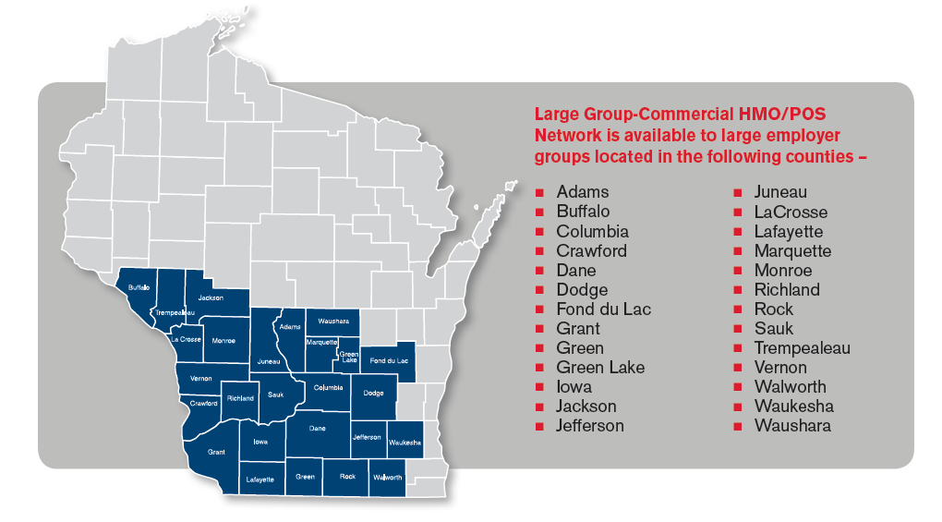

Delta Dental
- $50 /$150 Deductible
- 100% preventive
- 80% basic
- 50% major
- $1,000/year max per person
- Child orthodontia -$1,000 lifetime

W2 Hourly
Employee – $19.93
Employee/Spouse – $39.28
Employee Children – $40.67
Family - $70.36
Salary
Employee - $0
Employee/Spouse – $19.35
Employee/Children – $20.74
Family - $50.43
Delta Vision
- Exam $10 in network
- Frames $150 allowance, then 20% off balance
- Lenses $10 in network
- Contact lenses $150 allowance, then 15% off balance
- Contact lenses medically necessary covered in full
Employee - $3.25
Employee/Spouse - $6.50
Employee/Child(ren) - $6.64
Family - $9.89
Quartz Coverage

